Checks are to be completed at a frequency determined by the business based on shift patterns and number of staff. This is to ensure reasonable measures are in place, controls are being implemented.
Click here for updates.
Business: Click here to enter text. |  |  | Check completed by: Click here to enter text.
Date: Click here to enter text. |  |  | Time: Click here to enter text.
Click here for source
Record the time of the check and answer questions Yes/No/N/A, any comments record on the reverse |  |  |  |  |  | Yes | No | N/A
Start of shift  - Staff fit and well no covid-19 symptoms reported?  - Any briefs or updates from the company or government guidelines required?  - Any feedback from previous day e.g. complaints measure not being followed?  - Social distancing adhered to?  - Handwashing adhered to? |  |  |  |  |  | ☐s: | ☐ | ☐
Area – Changing Area  - Signage in area explaining social distancing rules and maximum capacity allowed, is it being followed?  - Clean uniforms available (where required)? |  |  |  |  |  | ☐s: | ☐ | ☐
Area – Corridors  - Signage in staff areas – keep 2-metre social distancing no stopping to chat?  - Where possible doors kept open to prevent touching of door handles? (n.b. security, fire safety and pest access must be considered) |  |  |  |  |  | ☐s: | ☐ | ☐
Area – Canteen/Lunch Breakout area  - Breaks staggered, to prevent over capacity?  - Tables laid out to allow 2-metre social distancing? Alternative areas available one way in and one way out labelled, if possible?  - Signage on display – keep 2-metre social distancing?  - Tables being cleaned after use (using disposable cloths and BSEN 1276 sanitiser? |  |  |  |  |  | ☐s: | ☐ | ☐
Area – Handwashing  - Signage on display – keep 2-metre social distancing 1 in, 1 out of area?  - Warm water, hand wash, paper towel, and sanitiser available?  - Signage on display – correct handwashing technique  - Hand sanitiser |  |  |  |  |  | ☐s: | ☐ | ☐
Area – Work Areas  - Organised allowing 2-metre social distancing, side to side working etc.  - Floor markings in place  - Signage on display – keep 2-metre social distancing?  - Cleaning schedules being completed (Surfaces cleaned regularly using BSEN 1276 sanitiser?)  - Staff following procedures |  |  |  |  |  | ☐s: | ☐ | ☐
Area- Customer access  - Queuing  - Social distancing messages in place/Signage clear  - 1 way system  - Staff making sure customers are following the guidelines |  |  |  |  |  | ☐s: | ☐ | ☐
Area-Visitors  - Advised on company’s risk assessment and controls before entering site |  |  |  |  |  | ☐s: | ☐ | ☐
Comments |  | Action taken, completed by, time and date
Click or tap here to enter text. |  | Click or tap here to enter text.
Click or tap here to enter text. |  | Click or tap here to enter text.
Click or tap here to enter text. |  | Click or tap here to enter text.
Click or tap here to enter text. |  | Click or tap here to enter text.
Click or tap here to enter text. |  | Click or tap here to enter text.
Click or tap here to enter text. |  | Click or tap here to enter text.
Click or tap here to enter text. |  | Click or tap here to enter text.
Signature: | Click or tap here to enter text. |  |  | Date: | Click or tap here to enter text.
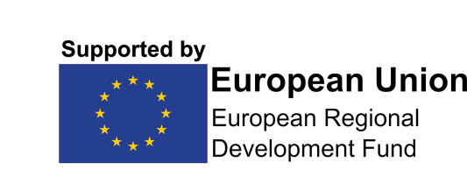
COVID READY is part funded by the European Regional Development Fund via the Reopening High Streets Safely Fund.

